**CAPSTONE PROJECT**

**Project: Health care Data Analysis**

**Data Ingestion: Prescriber Report**

**step1:**

hdfs dfs -mkdir -p prescpipeline/staging/prescriber

hdfs dfs -put USA_Presc_Medicare_Data_12021.csv prescpipeline/staging/prescriber

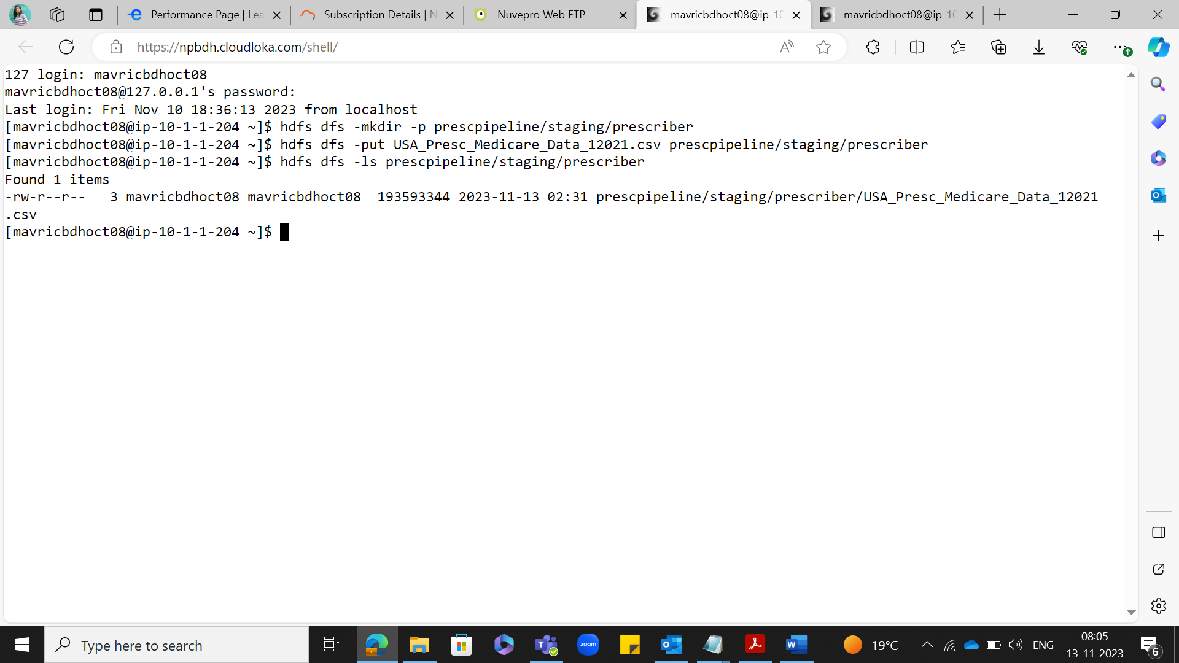

Hdfs dfs -cat prescpipeline/staging/prescriber/USA_Presc_Medicare_Data_12021.csv | wc -l

**step2:** prescriberDF=spark.read.option("header",True).option("inferschema",True).csv("prescpipeline/staging/prescriber/USA_Presc_Medicare_Data_12021.csv")

prescriberDF.printSchema()

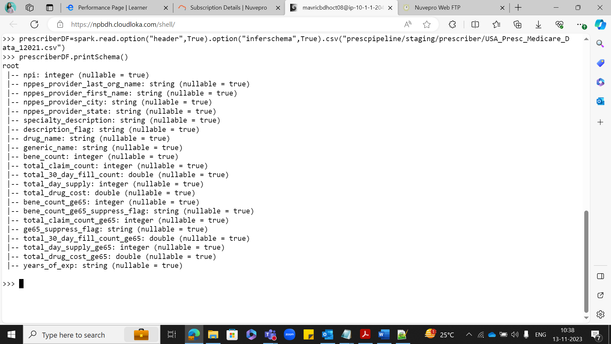

prescriberDF.show(10)

prescriberDF.count()

**Data Cleansing/Preprocessing:**

**Step1:** Selecting the required columns:

pres_step1_df=prescriberDF.select('npi','nppes_provider_last_org_name','nppes_provider_first_name','nppes_provider_city','nppes_provider_state','specialty_description','drug_name','total_claim_count','total_day_supply','total_drug_cost','years_of_exp')

**Step2:** **Rename the above fields to shorter names:**

prescriberDF1=prescriberDF.select('npi',(prescriberDF.nppes_provider_last_org_name).alias ('np_Lname'),(prescriberDF.nppes_provider_first_name).alias ('np_Fname'),(prescriberDF.nppes_provider_city).alias ('np_city'),(prescriberDF.nppes_provider_state).alias ('np_state'),(prescriberDF.specialty_description).alias ('spcl_desc'),(prescriberDF.drug_name).alias ('drug_nm'),(prescriberDF.total_claim_count).alias ('tot_claim_cnt'),(prescriberDF.total_day_supply).alias ('tot_day_suply'),(prescriberDF.total_drug_cost) .alias ('tot_drug_cst'), (prescriberDF.years_of_exp) .alias ('yrs_of_exp'))

prescriberDF1.printSchema()

**step3:** **Add a Country Field 'USA' to the above data**

from pyspark.sql.functions import col, lit

prescriberDF1=prescriberDF1.withColumn("Country", lit("USA"))

prescriberDF1.printSchema()

prescriberDF1.show(3)

**Step 4: Clean the “years_of_exp” to extract only the numbers.**

import pyspark.sql.functions as f

pres_step1_df=pres_step1_df.withColumn("yrs_of_exp",f.regexp_extract("yrs_of_exp", r'([0-9]+)', 1))

**Step5:Convert the years_of_exp field to integer**

from pyspark.sql.types import IntegerType

prescriberDF2 = prescriberDF1.withColumn("yrs_of_exp", prescriberDF1["yrs_of_exp"].cast(IntegerType()))

prescriberDF2.printSchema()

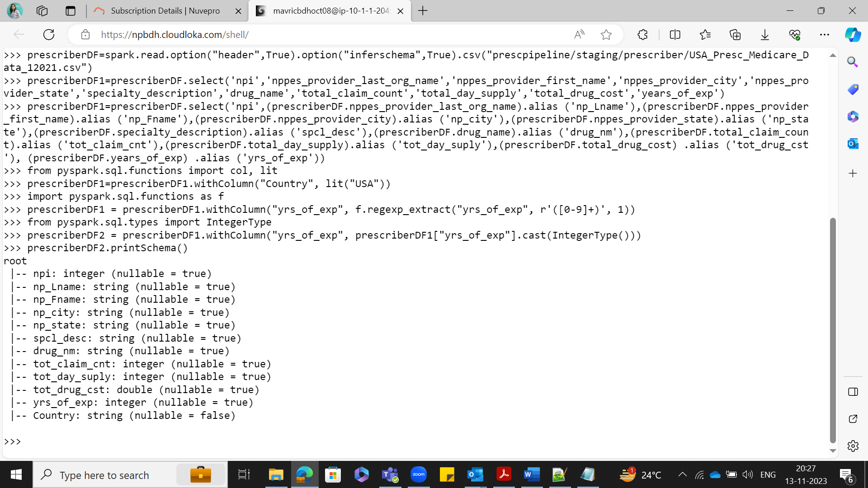

**step6:Combine First Name and Last Name in to a single field and remove the individual columns**

from pyspark.sql.functions import concat, concat_ws,col, lit

prescriberDF2 = prescriberDF2.withColumn("presc_fullname",concat_ws(" ", "np_Fname", "np_Lname"))

prescriberDF2.show(5)

**Removing individual columns**

prescriberDF2 = prescriberDF2.drop("np_Fname", "np_Lname")

prescriberDF2.show(3)

**Step7:Count the number of null values for each column**

from pyspark.sql.functions import col,isnan, when, count

prescriberDF2.select([count(when(isnan(c) | col(c).isNull(),c)).alias(c) for c in prescriberDF2.columns]).show()

**Step8: Clean all the Null/Nan Values**

Delete the records where the PRESC_ID and DRUG_NAME is fields are NULL. Use dropna() of dataframe

prescriberDF2 = prescriberDF2.na.drop(subset=["npi"])

prescriberDF2 = prescriberDF2.na.drop(subset=["drug_nm"])

prescriberDF2.printSchema()

prescriberDF2.select([count(f.when(isnan(c) | col(c).isNull(),c)).alias(c) for c in prescriberDF1.columns]).show()

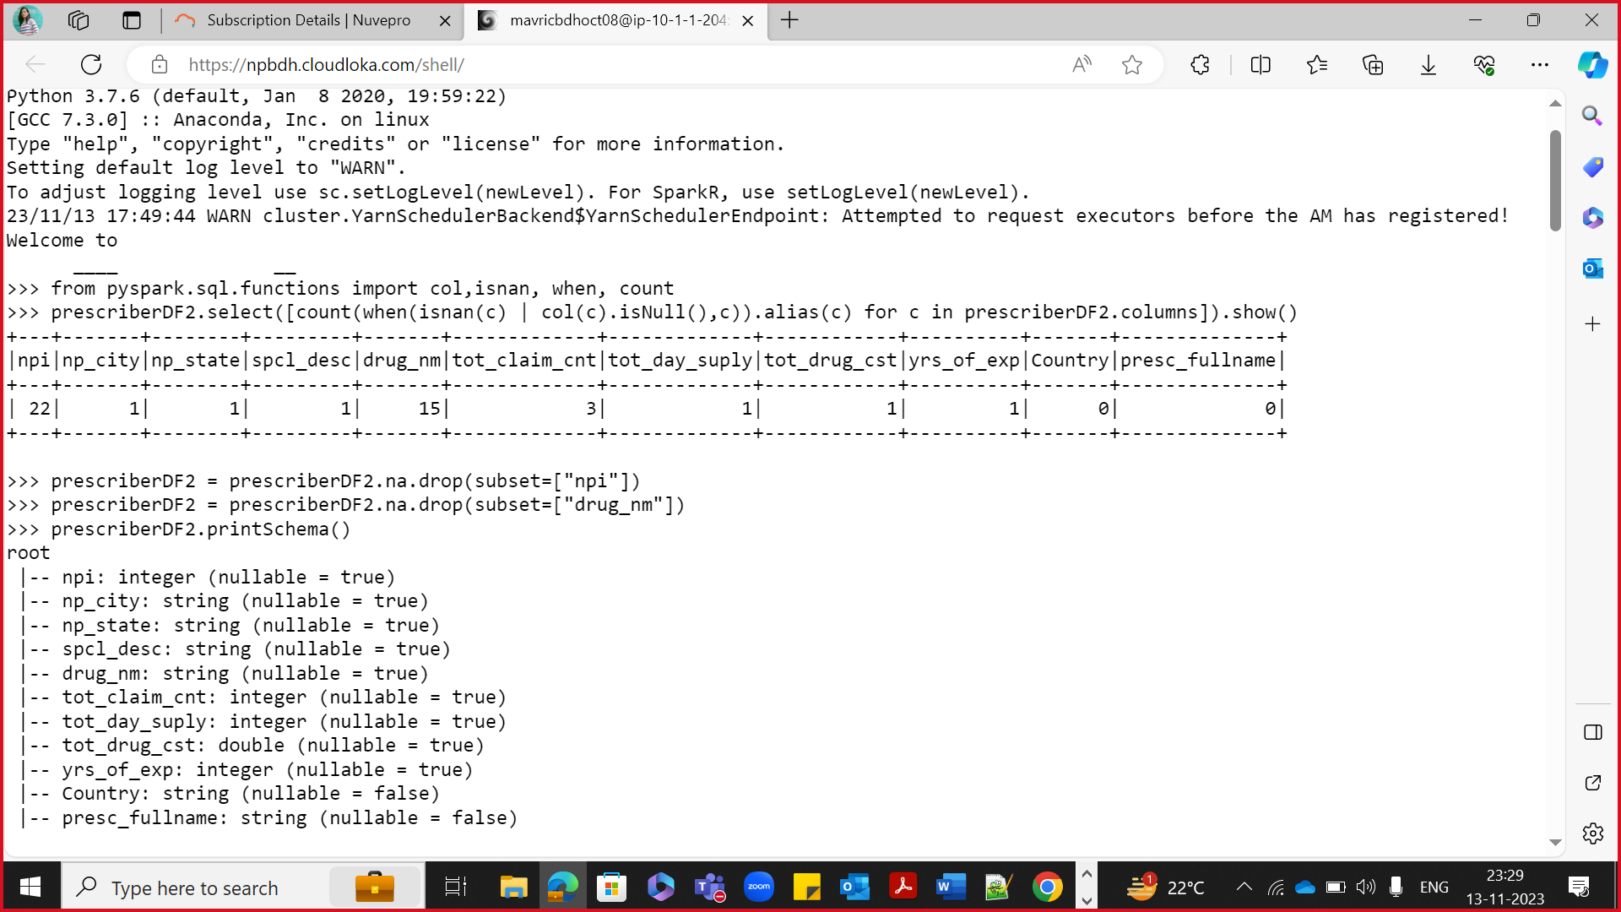

**Transformations:**

**Step 1 :Transformation**

**Transform logic: Prescriber Report:**

Top 5 Prescribers with highest total_claim_count per each state.

Consider the prescribers only from 20 to 50 years of experience.

from pyspark.sql import functions as F

prescriberDF2 = prescriberDF2.filter(F.col("yrs_of_exp").between(20,50))

prescriberDF2.createOrReplaceTempView("prescriber")

spark.sql("SELECT min(yrs_of_exp) , max(yrs_of_exp) from prescriber").show()

from pyspark.sql import Window

from pyspark.sql.functions import dense_rank

from pyspark.sql.functions import concat, concat_ws,col, lit

window = Window.partitionBy("np_state").orderBy(col("tot_claim_cnt").desc())

prescriberDF2 = prescriberDF2.withColumn("tot_claim_cnt_rank", dense_rank().over(window))

prescriberDF2.createOrReplaceTempView("prescriber")

spark.sql("SELECT npi as Prescriber_ID , presc_fullname as Prescriber_Full_Name, np_state as Prescriber_State,Country as Prescriber_Country, yrs_of_exp as Prescriber_Years_of_Experience,tot_claim_cnt as Total_claim_count,tot_day_suply as Total_Days_Supply,tot_drug_cst as Total_Drug_Cost from prescriber where tot_claim_cnt_rank <= 5").show()

****Run in HDFS***

hdfs dfs -mkdir -p prescpipeline/output/prescriber

**Writing the output into HDFS in ORC format and snappy compression :**

from pyspark.sql import SparkSession

spark=SparkSession.builder.appName("SparkHive").enableHiveSupport().config("spark.sql.warehouse.dir","/user/hive/warehouse").getOrCreate()

spark.sparkContext.setLogLevel("ERROR")

prescriber_report_DF = spark.sql("SELECT npi as Prescriber_ID , presc_fullname as Prescriber_Full_Name, np_state as Prescriber_State,Country as Prescriber_Country, yrs_of_exp as Prescriber_Years_of_Experience,tot_claim_cnt as Total_claim_count,tot_day_suply as Total_Days_Supply,tot_drug_cst as Total_Drug_Cost from prescriber where tot_claim_cnt_rank <= 5").show()

prescriber_report_DF.write.mode("overwrite").option("compression","snappy").orc("/user/mavricbdhoct08/prescpipeline/output/prescriber")

**checking the output report file generated in hdfs:**

hdfs dfs -ls /user/mavericbdhoct08/prescpipeline/output/prescriber

**OUTPUT: HDFS**

[mavricbdhoct08@ip-10-1-1-204 ~]$ hdfs dfs -ls prescpipeline/output/prescriber

Found 54 items

-rw-r--r-- 3 mavricbdhoct08 mavricbdhoct08 0 2023-11-14 09:07 prescpipeline/output/prescriber/_SUCCESS

-rw-r--r-- 3 mavricbdhoct08 mavricbdhoct08 1510 2023-11-14 09:07 prescpipeline/output/prescriber/part-00004-466c88f0-5c21-4858-996c

-2850e19a82ab-c000.snappy.orc

-rw-r--r-- 3 mavricbdhoct08 mavricbdhoct08 1319 2023-11-14 09:07 prescpipeline/output/prescriber/part-00009-466c88f0-5c21-4858-996c

-2850e19a82ab-c000.snappy.orc

**OUTPUT: HIVE Beeline**

prescriber_report_DF.write.partitionBy("Total_claim_count").mode("overwrite").saveAsTable("indhudb.prescriber_Final_report")

use indhudb;

show tables;

select * from prescriber_Final_report order by Total_claim_count desc ;

